1. Hill function fitting

After the formal research and test we’ve taken, the florescence – concentration of ths/ttr can be fitting into this formula:

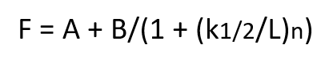

F = Florescence

A = the fit of the minimum response with no thiosulfate

B = the maximum response at saturating thiosulfate concentration

k1/2 = concentration of thiosulfate at half maximum response

n = Hill coefficient

Thus, we tried to fit data into these formula and succeeded.

1. Top10 and Nissle bacteria with GFP system in aerobic and anaerobic environment

After the testing with Flow Cytometry, we’ve gotten the following data with the ths sensor:

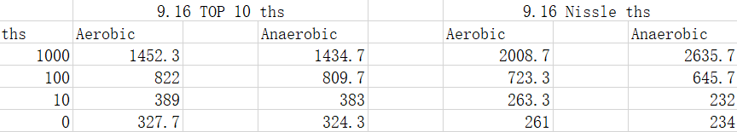From these data, we can clearly find that the florescence of bacteria is growing while the concentration of ths is grow.

We tried Hill function that mentioned before to fit the data, and we found that the data can be fitted in Hill Function perfectly. The figure fitted by matlab is showing bellow:

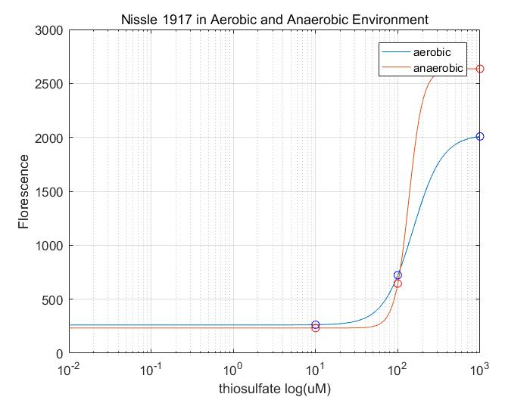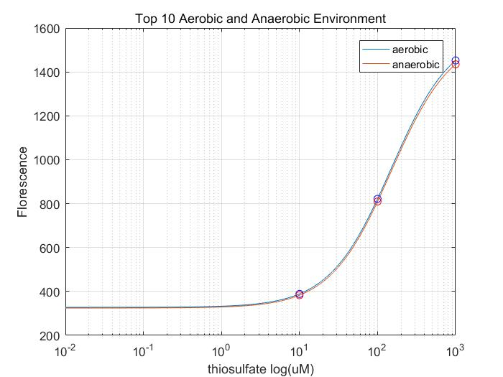However, the data of bacteria with ttr sensor didn’t work very well.

Also, the data we tested is only four kinds of concentration: 0mM, 0.01mM, 0.1mM, 1mM. Thus, we decided to have second test on GFP system.

1. Top10 and Nissle 1917 with GFP system in aerobic environment (more Data)

For this time, we’ve tested 7 kinds of concentration: 0mM, 0.01mM, 0.05mM, 0.1mM, 0.3mM, 0.7mM, and 1mM.

The data of second time is showing bellow:

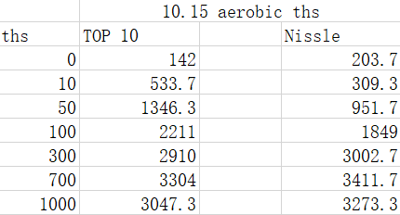

After inputting these data into the matlab, we’ve gotten the figure showing bellow:

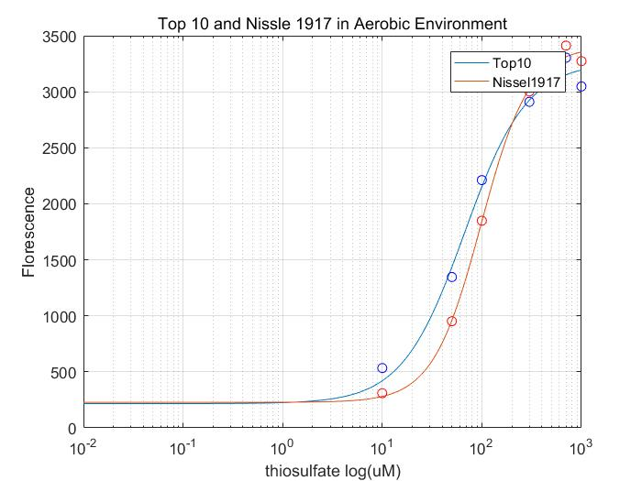At same time, the ttr sensor still didn’t work, so the data cannot be fitted.

Now, we are going to test bacteria with chromoprotein.

1. Top10 and Nissle 1917 with chromoprotein in aerobic and anaerobic environment
2. Code and Citation

The code of modeling has been uploaded to GitHub:

<https://github.com/AzirQuantum/SHSBNU_China_2017>